SQL Assignment – 11
D2-83822-Rohit
Subqueries

1) Write a query that uses a subquery to obtain all orders for the customer named Cisneros. Assume you do not know his customer number (cnum).

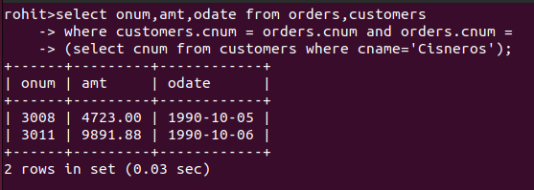

2) Write a query that produces the names and ratings of all customers who have above-average orders.

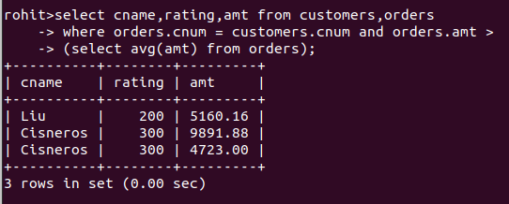

3) Write a query that selects the total amount in orders for each salesperson for whom this total is greater than the amount of the largest order
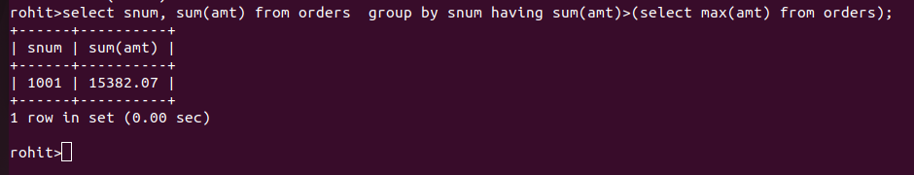
in the table.

